EEL4436C/5437C Microwave Engineering

Homework #6

1. (25 pts) Attenuators are extremely useful in microwave applications. They are used as compact matching networks (in case one can “throw away” power), and also reduce the level of signal before diode detectors or mixers so as to stay away from the saturation regime. One common way of building a matched attenuator is shown below:

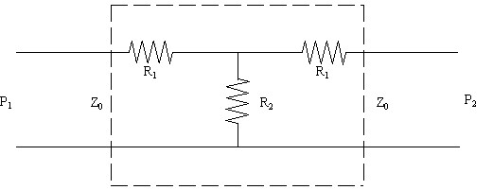

For P2 = 0.5 P1, calculate R1 and R2. This is a 3 dB attenuator. You need to use the definition of S parameters to derive the formulas like the example shown in the lecture.

Form the lecture, the S matrix for attenuator is,

Solve for ,

Under this constraint,

and

The following is the equivalent circuit for ,

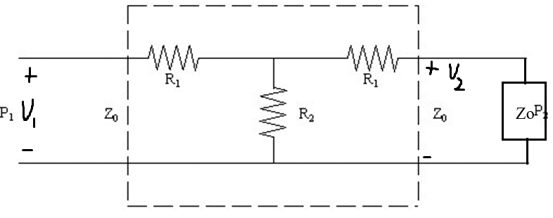

After numerical computation, the following resistor values were chosen,

2. (25 pts) a) Calculate the scattering matrix for the following circuit:

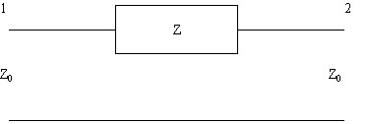

b) If Z=R, calculate R so that maximum power is absorbed in R. What is |S11|2 and |S21|2in this case? Calculate the power absorbed in R.

1. (25 pts)a) Write the scattering matrix for the following circuit (R=0.5Z0):

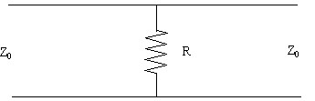

b) A low-cost “splitter” is used which results in a matched T-junction at the expense of some loss in the network. Write the scattering matrix for the following circuit:

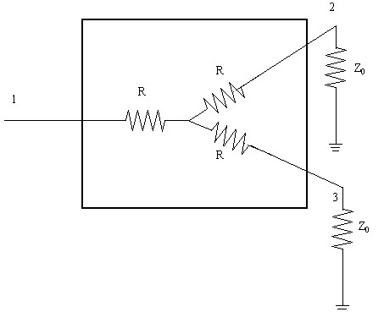

“splitter”

c) Write the scattering matrix for the matched -10dB attenuator (P2=0.1P1).



1. (25 pts) a) Using the properties of the Scattering matrix, prove that it is impossible to build a matched, lossless and reciprocal 3-port network.

b) Using the S-parameter matrix, prove that any 4-port device matched at all ports and lossless, with two planes of symmetry, must be a 90° coupler.

1

3

2

4

Geometrical planes of symmetry

(i.e., if you flip it left to right or down to up, it will always be the same circuit)